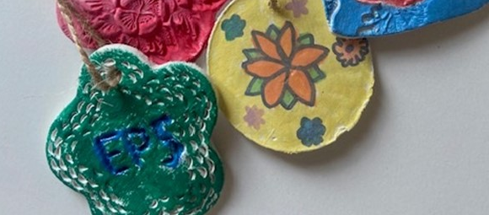
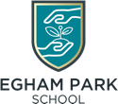
EGHAM PARK SCHOOL

Message from your Principal, Nicki
As our Year 11 students embark on the next exciting journey into their educational career, I want to congratulate all of you for everything that you have achieved in your time with us. I will miss each and every one of you, so please do stay in touch.

Welcome too, to all of our new starters! We are all looking forward to you joining us!
I also want to take this opportunity to thank everyone who is involved with supporting our school community, students, parents, carers, staff, volunteers and our Advisory Board. We are so grateful for your continued support.

Wishing you all a happy, healthy, and stress-free holiday period!

Nicki


NEWSLETTER

A huge thank you from your Team

Thank you to all of our parents, carers and pupils for your continued support. We hope that you have a lovely summer Break.
Sayers Croft Trip

At the end of March the pupils enjoyed a fun-filled and exciting day on the beautiful grounds of Sayers Croft, being nature detectives who searched for insects and built shelters with logs in the woodlands. The most exciting part of the day was the Gladiator Challenge which all pupils succeeded in with flying colours.

The pupils all had a go and were very willing to try something new. A great day had by all.

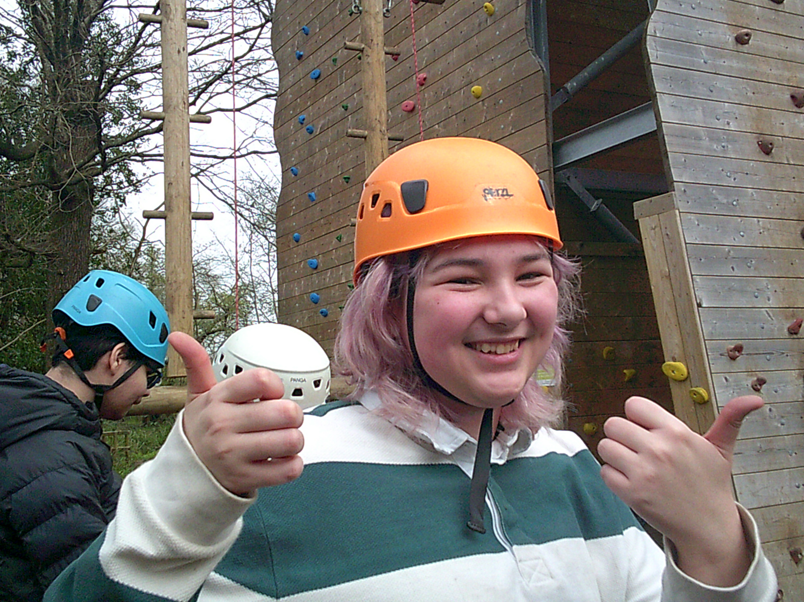

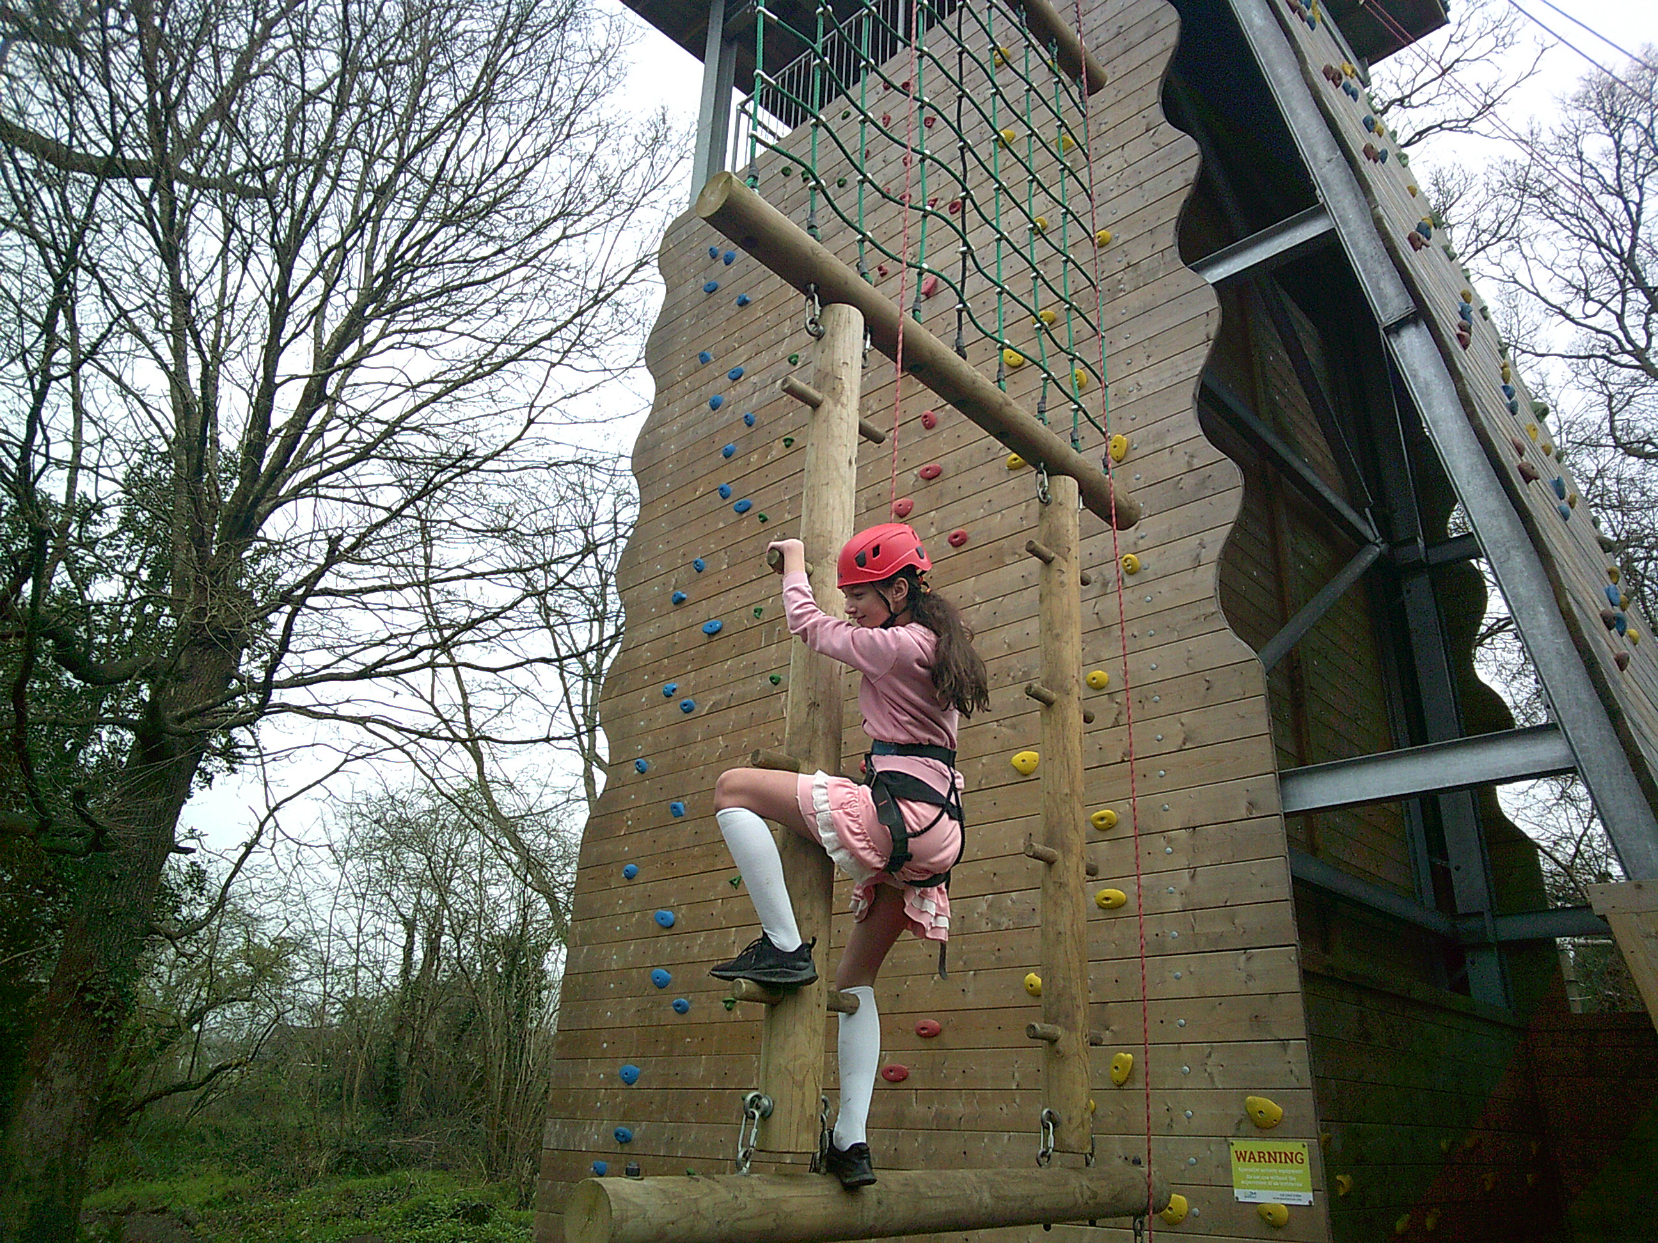

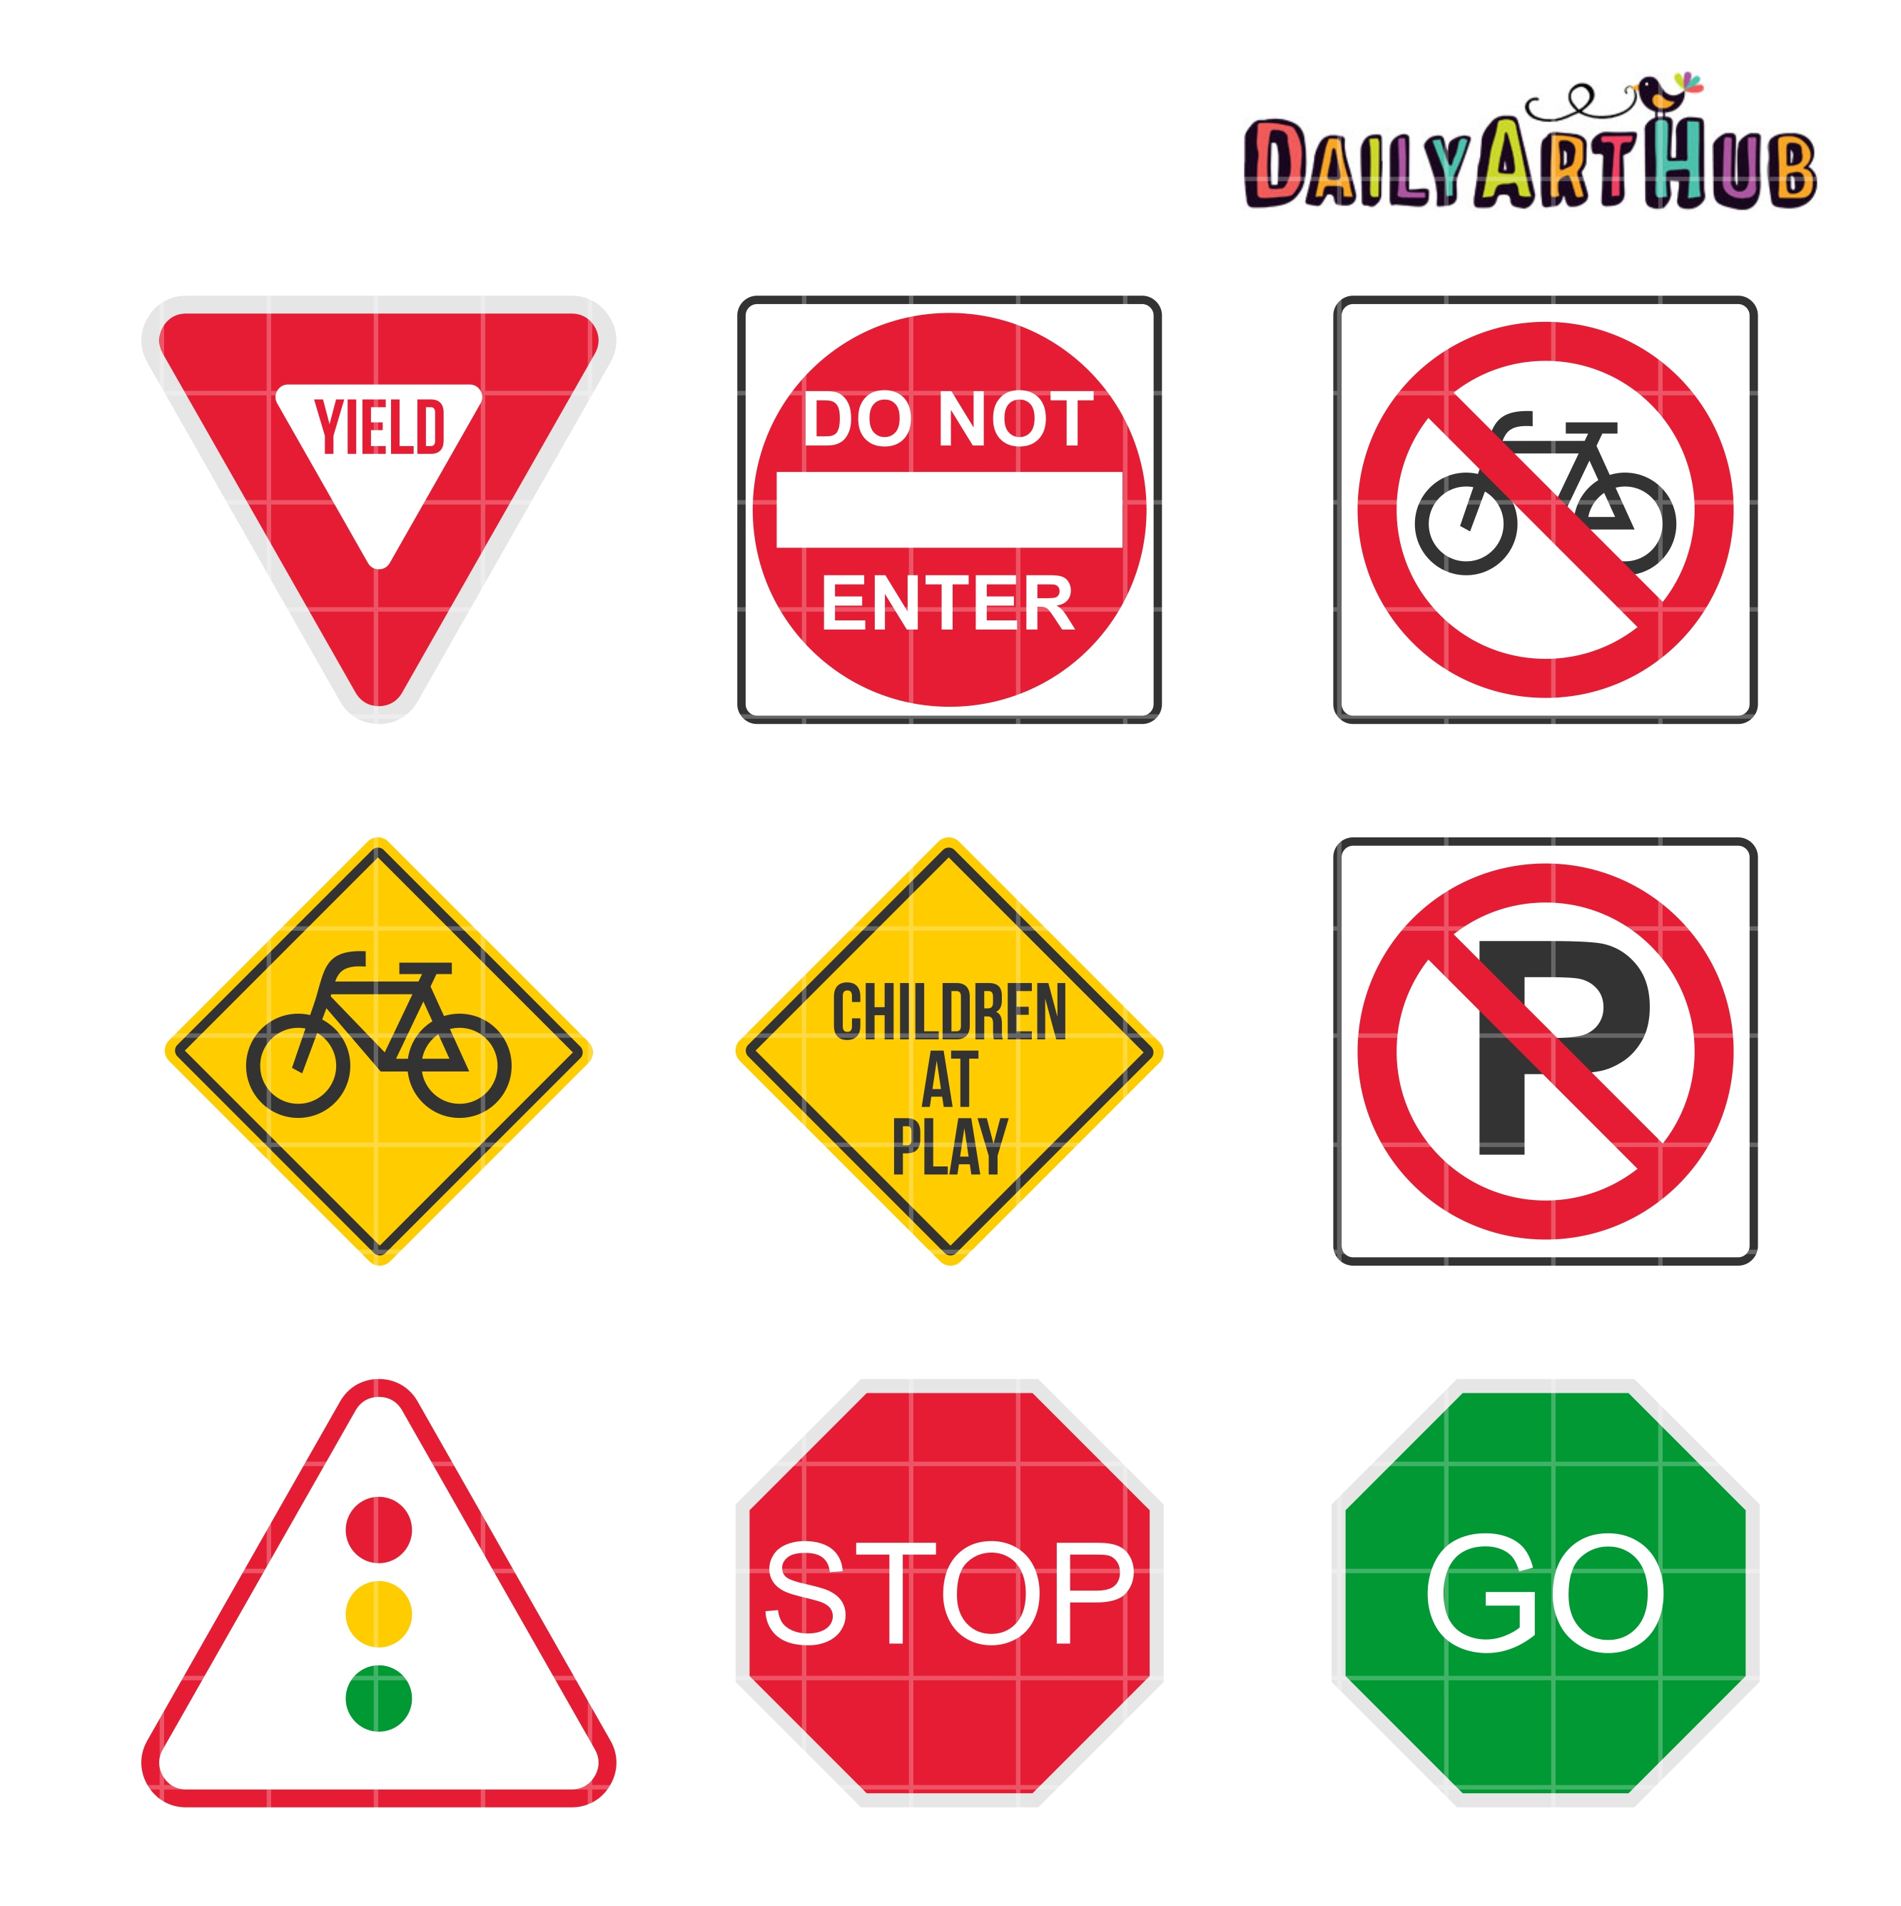
Safety First!
Pupils developed their road safety by exploring and learning about various road signs. They tested their knowledge on a walk through Egham, identifying road signs and by completing a road signs card game.

Our environment
This term the pupils explored aspects of the school’s local area, starting with a survey of local trees. On a ‘Pollinator Walk’ students also assessed how bee-friendly local front gardens are, after learning about the importance of bees and other insects for the environment. Pupils designed some beautiful posters with advice on how to garden in a bee-friendly way.

National Trust
As the funding for the project stopped the pupils are now volunteering. They are building on their social skills and looking after the environment with various activities such as litter picking, greeting visitors and handing out flyers.

Magna Carta
Egham Park had a stall, for the second year running, at the Magna Carta day. Staff manned the stall for the day and students came to help out as well from bartering with buyers, handing out leaflets or answering any questions that customers had. This was all a part of the student's enrichment and enterprise. The pupil's, staff and volunteers handmade all products to sell. These ranged from, hair scrunchies to personalised tote bags, even 3D printed fidget made by one of our volunteers! We stayed through torrential rain and sunshine. We really appreciate everyone who came, Staff and students!

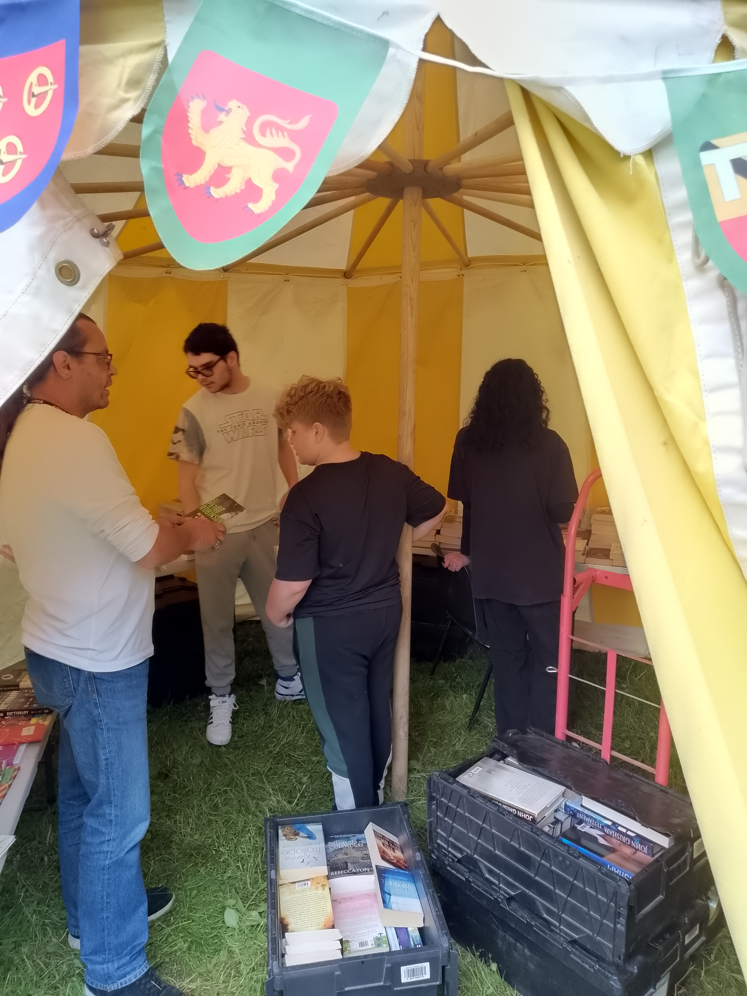

Following an invitation from the National Trust to their ‘Runnymede Explored’ event at the Egham NT Tea Rooms, the pupils, who have volunteered at the NT this half term, had the opportunity to try their hands on some old-fashioned games, with archery proving to be by far the most popular.

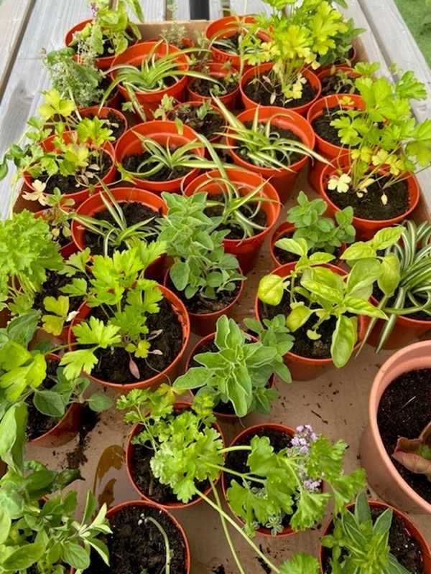

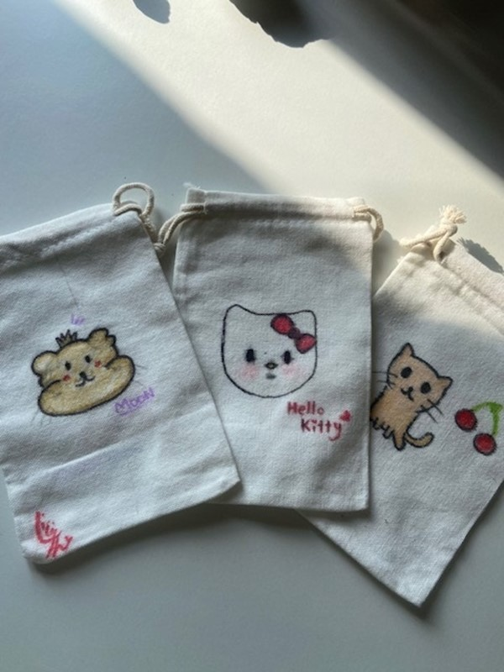

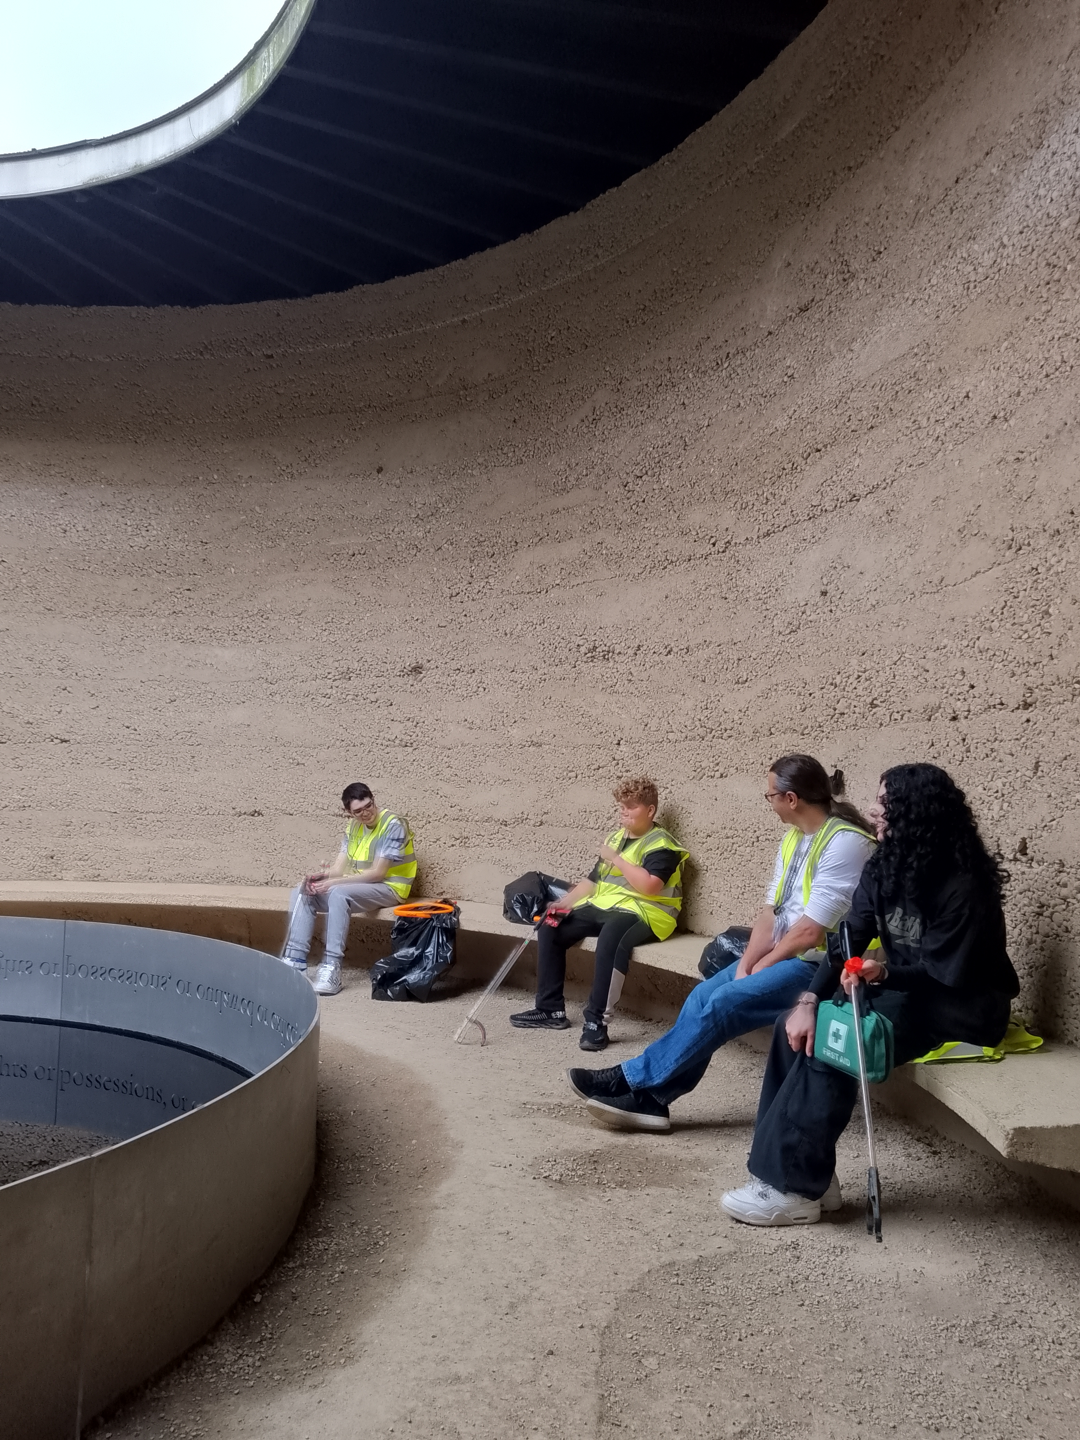

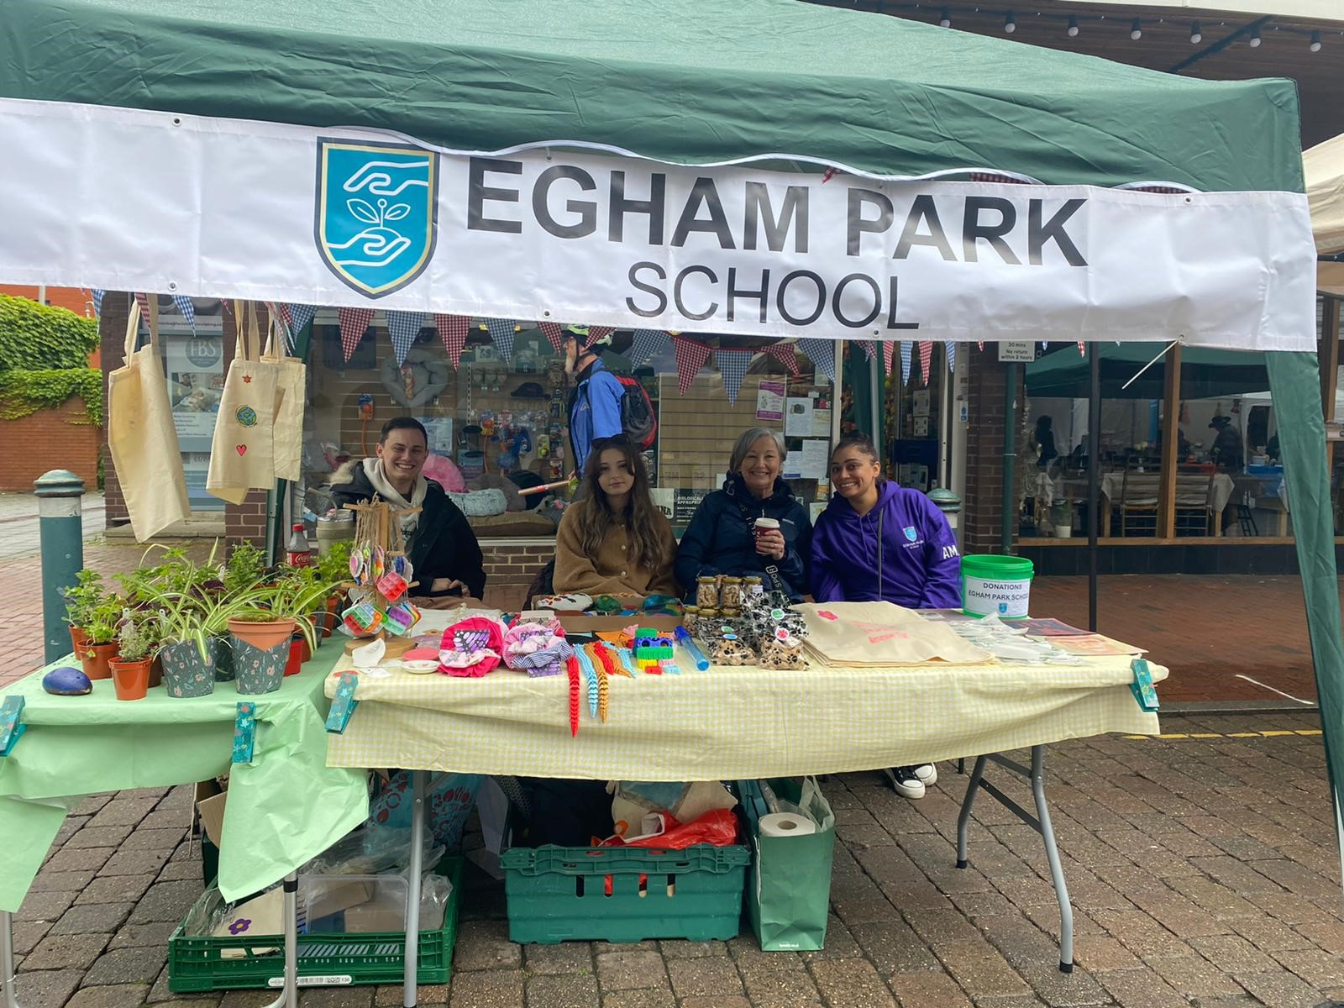

End of term trip to Go Ape

The highlight of this half term was the trip to Go Ape in Bracknell Forest. After safety training and being put into harnesses pupils and staff took to the treetops, working their way across various obstacles, jumping into cargo nets and zooming down zip wires. It was impressive how all pupils took responsibility for their safety and showed great courage and perseverance, but above all – had lots of fun. We were lucky the weather was great too.

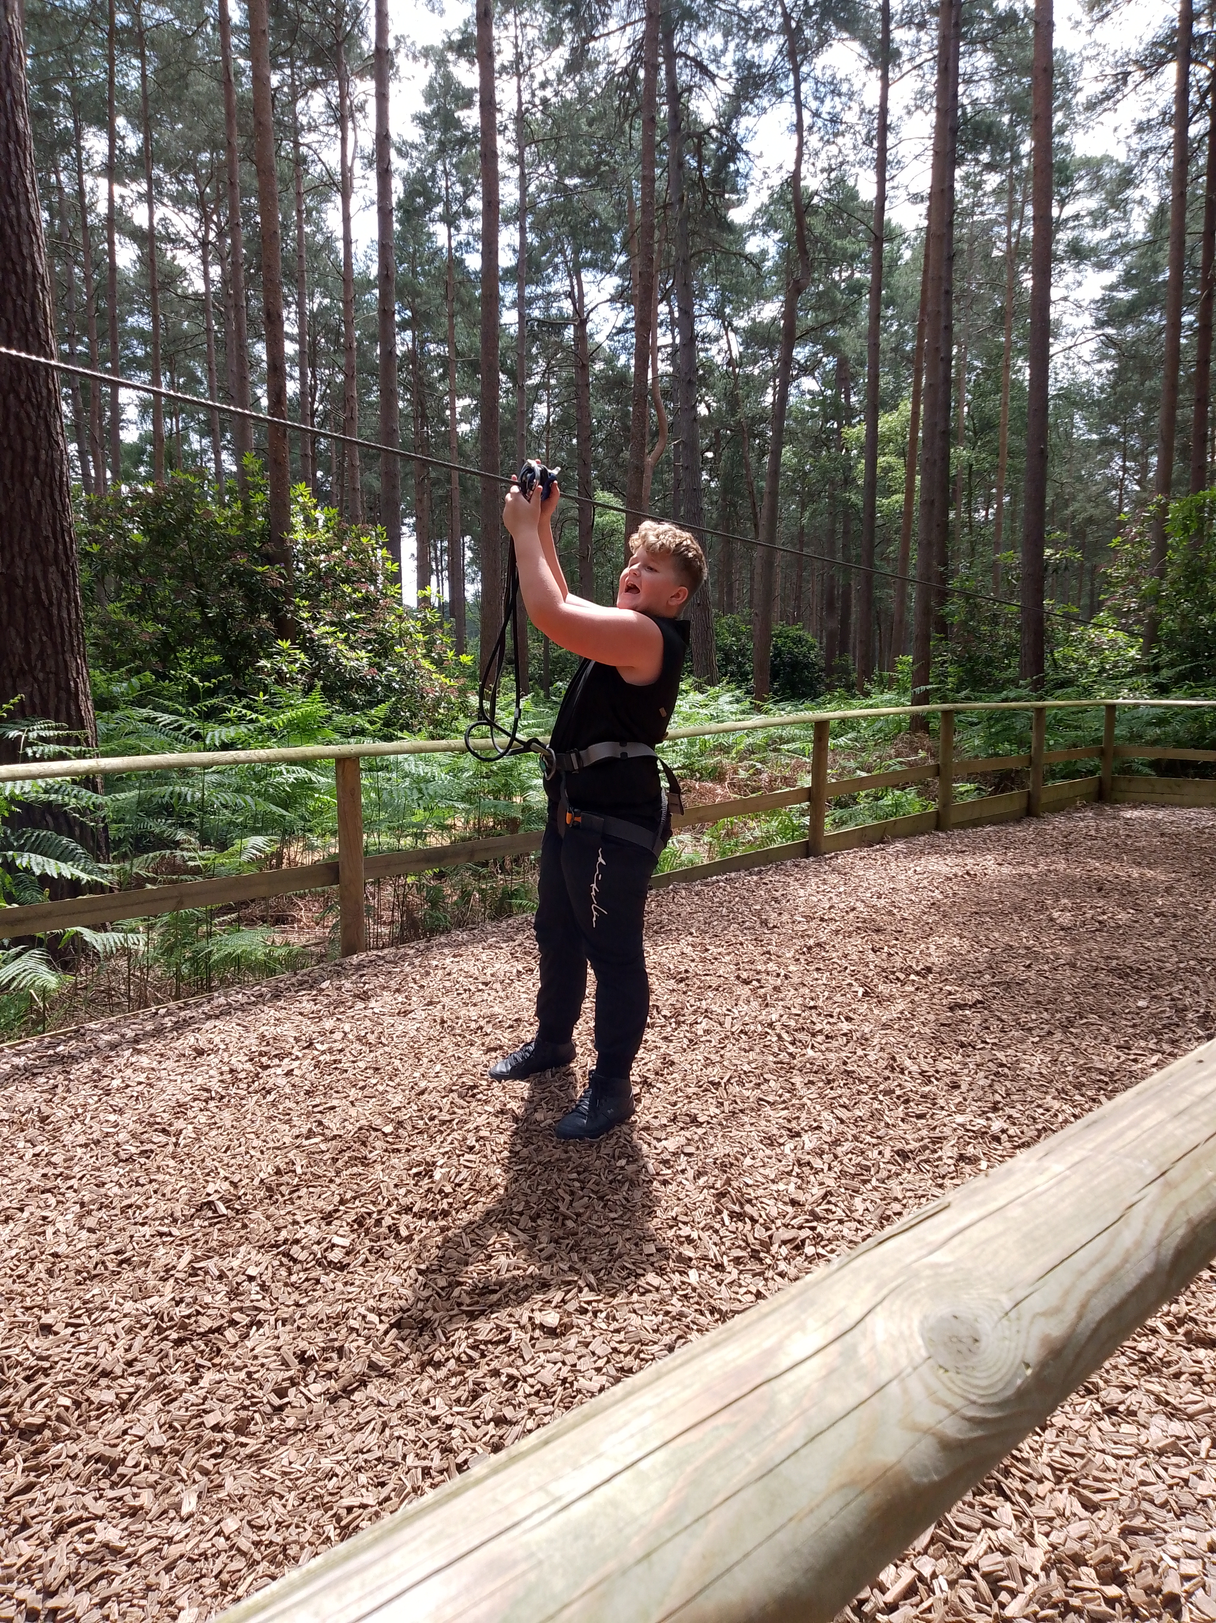

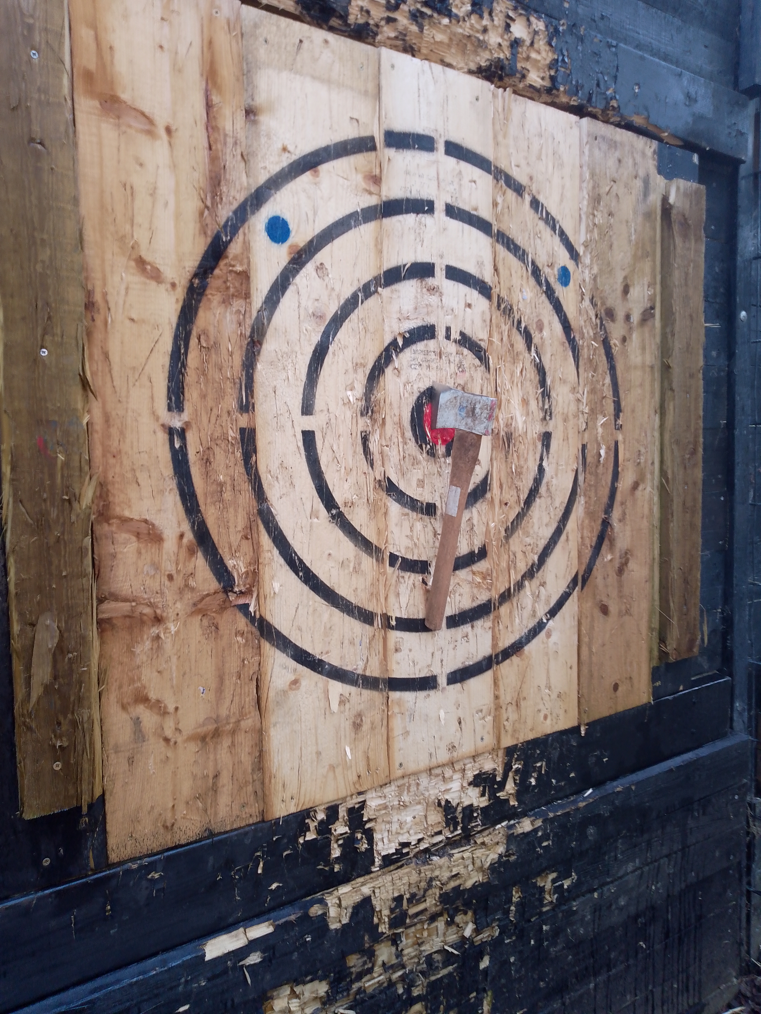

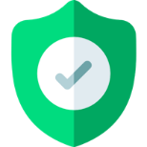


Absence and Sickness
For any absences, sickness or late arrivals please do contact the school on 01784 913929 or email Amar at apanesar@eghamparkschool.co.uk by 8.30am.

Changes in personal details
Should any of your personal details change or anything regarding your child’s medical history etc please can you let the team know and email Amar at apanesar@eghamparkschool.co.uk


IMPORTANT INFORMATION
Your feedback is always important to us. This can be anything from something we need to improve on, something we can change or something we are doing well. Please do share this with us by emailing Nicki or Amar.
Thank you

New Pupils
In September we will be welcoming four new pupils, from a variety of age groups. The new pupils have been transitioning for some time to make their next steps as easy as possible. We are delighted to have our new young people join us but saddened to see our leavers depart. We have thoroughly enjoyed getting to know our new pupils.

Safeguarding over the summer break
Over the break, we are still here for all our pupils and families.

If you have any non-urgent concerns or questions, you can email the school on:

Listening@eghamparkschool.co.uk

Emails sent to this email address will be answered as quickly as possible but may take up to 24hours for a response.

In case of an emergency please call:
999

If you require support from the Local Authority: Please contact:

cspa@surreycc.gov.uk
0300 470 9100

Leavers
We sadly have four year 11 pupils leaving us this year. Thank you for being an integral part of our school community. We wish you all the best in your future endeavours and look forward to seeing the amazing things you will achieve.
Congratulations and good luck! You will be missed!

